A1503-AM,S-Peru-Chimu-Textile-Loincloth-100-400 CE

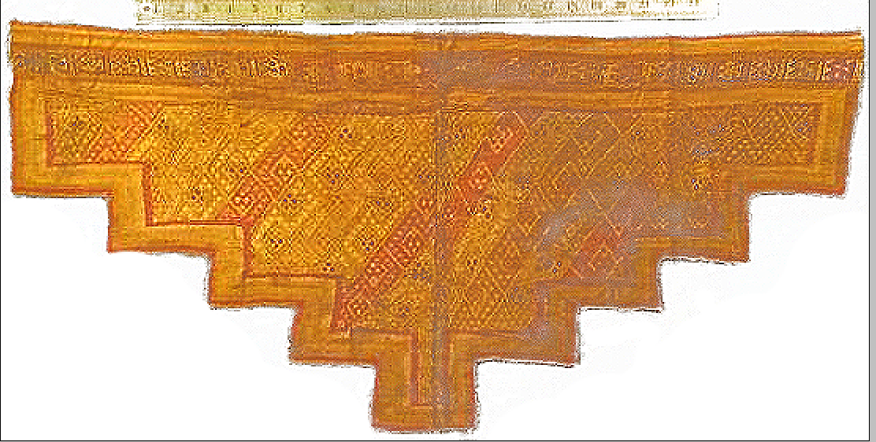

Fig. 1. Peru-Chimu-Textile-Loincloth-100-400 CE

**Case no.: 7** Textiles

**Accession Number:** A1503

**Formal Label:** Peru-Chimu-Textile-Loincloth-100-400 CE **Display Description:** This tapestry panel loincloth was produced by Chimú weavers (100-400 AD/CE). Chimú culture was centered on Chimor,  a political constituent of Chimú culture that ruled the N coast of Peru 850-1470 AD/CE, before the Chimú were conquered by the Inca emperor Topa Inca Yupanqui. Chimor was the largest kingdom in the Late Intermediate period, encompassing 1,000 km (620 mi) of coastline centered on Chan Chan (“Resplendent Sun” in the Quingnam language), a city located 4 km (2.5 mi) NW of Trujillo, Peru (Kubler 1962: 247-274).

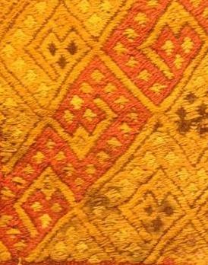

Fig 3. The apotropaic, double-headed, serpent motif terminating with a jaguar motif within the temple textile image proper.

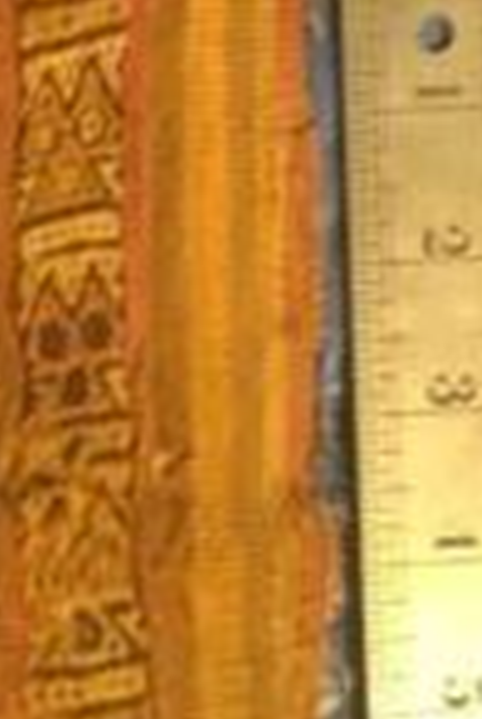

Fig. 2. Jaguar motif in the border of the tapestry

This toothed-crescent headdress style loincloth from the N coast of Peru has 16 diagonal registers of interlocking serpent zigzag motifs terminated with apotropaic jaguar heads that were intended to provide protection from any evil powers. The jaguar was the revered animal that played an important spiritual role in shamanic vision quests for South Americans in general and, combined with the serpent motif, it had a powerful apotropaic potency in the eyes of the Chimú These protective motifs had an important practical role, since the Chimú temple was not only a ritual center for worship but also an abode of the deceased Chimú elders who were buried in tomb-chambers constructed within the temple and were accompanied by rich grave goods, including gold objects. So security for these mortuary objects was an issue. Furthermore, the Chimú ciudadela practice of accumulating wealth beyond subsistence levels expressed a generalized concept of Chimú abundance (Pillsbury 1993: 281) and stealing was protected by lethal punishment (Rowe 1948: 49). These tapestry designs express repetition and standardization that communicated an important visual message that emphasized the pervasive power of accumulation of wealth and the legal power of government that supported it. This message appears to have continued as a key visual textile strategy for the Middle Sican (900 to 1100 AD/CE) and Chancay (1100-1400 AD/CE) Periods. This practice may have been predicated on the practice of “split inheritance,” wherein the deceased ruler retained possession of his estate post mortem and the incoming ruler was obliged to accumulate his own amount of wealth (including land titles which were extremely important visually) from the inception of his rule (O’Day 2000: 70). Such diversions from the ruling of a state entity was destructive to the day-to-day running of government, however.

**LC Classification:** F3430.1.C46

**Date or Time Horizon:** 100-400 AD/CE

**Geographical Area:** Chan Chan

**Map, GPS coordinates:** -12.18171 -76.92707; 40° 26' 46" N 79° 58' 56" W

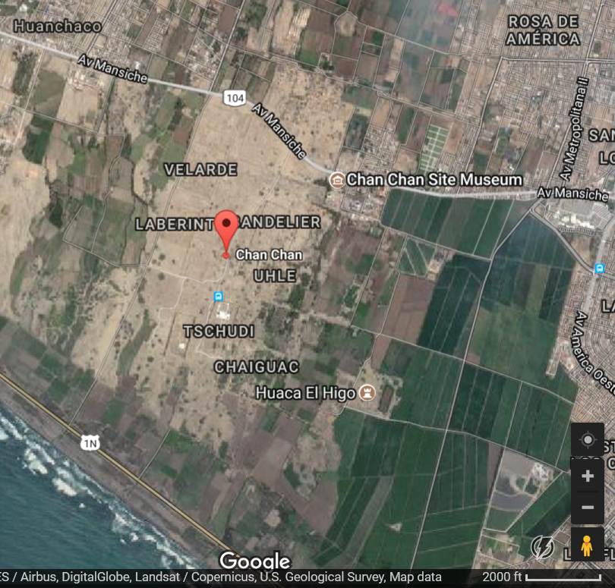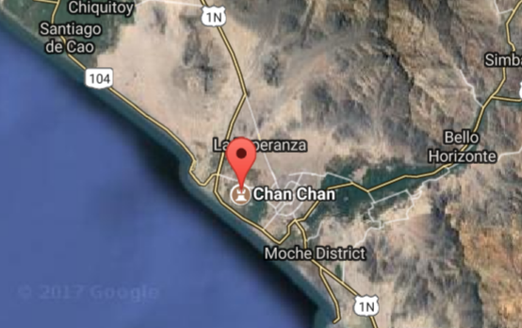

**Cultural Affiliation:** Chimú

**Media:** cotton and wool, yellow and orange vegetable dyes

**Dimensions:** L 32 in

**Weight:** 2 lbs

**Condition:** original.

**Provenance:** old New York Estate

**Discussion:** This loincloth is of similar dimensions and motif structure as another from the N coast of Peru of Chimú manufacture.

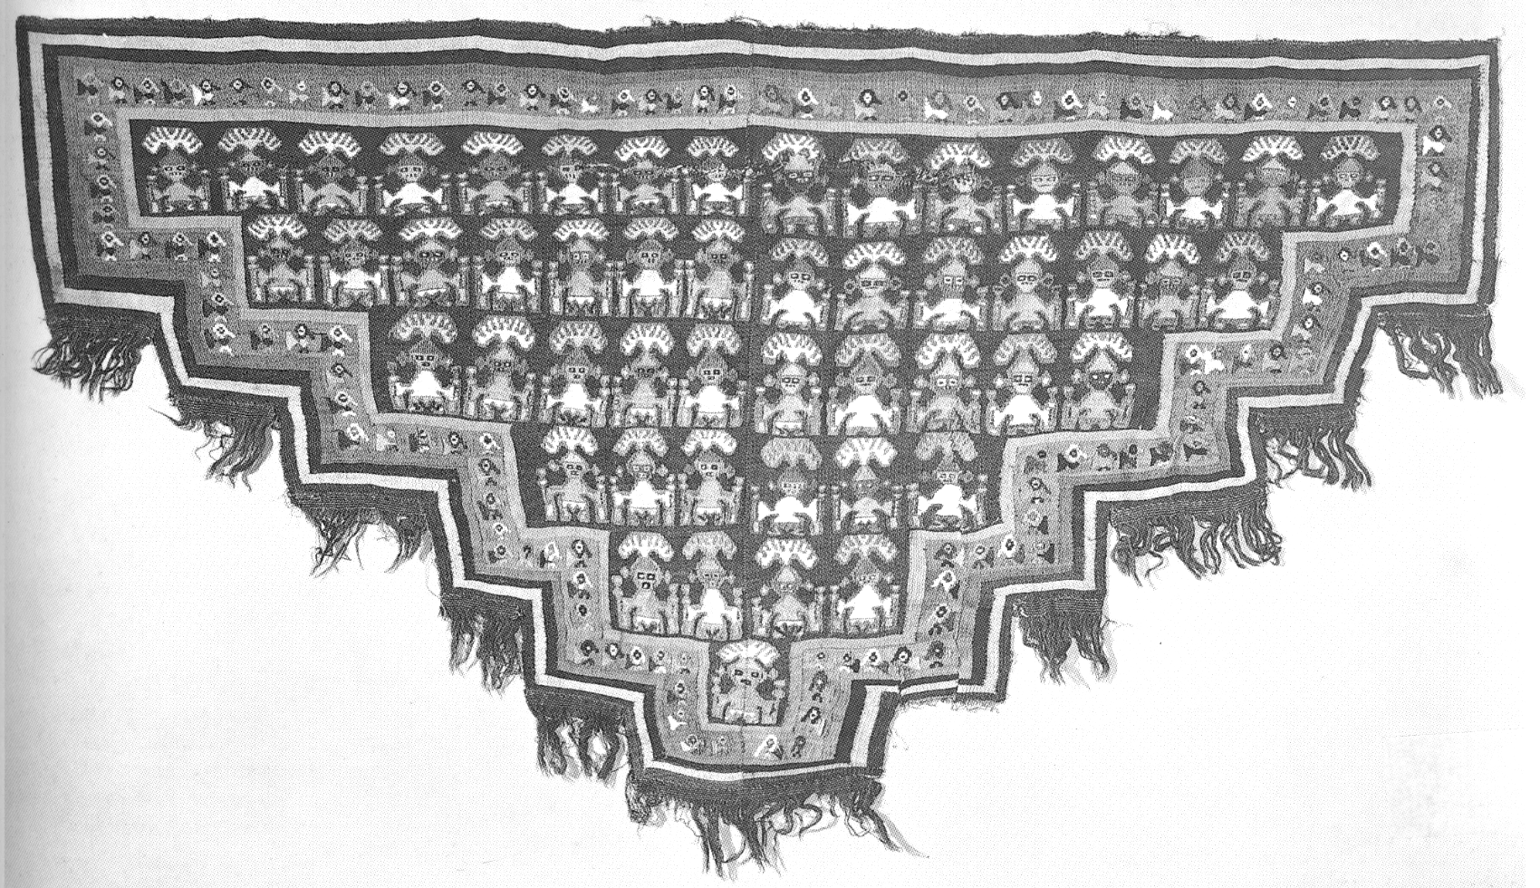

Fig. 4. Tapestry panel from a loincloth, cotton and wool, Toothed Crescent Headdress style, N Coast of Peru, Chimú (H 61.7 cm x L 107.5 cm). From O’Day 2000: 71, Fig. 3.10.

**References:**

Cameron, Ian. 1990. *Kingdom of the Sun God: a history of the Andes and their people.* New York: Facts on File.

Kubler, George. 1962. *The Art and Architecture of Ancient America*, Ringwood: Penguin Books.

Moseley, Michael E. 1992. *The Incas and their ancestors: the archaeology of Peru.* London: Thames and Hudson.

O’Day, Karen. 2000. “The goldwork of Chimor: the technology and iconography of wealth accumulation.” In Colin McEwan, *Pre-Columbian gold: technology, style and iconography.* London: British Museum Press), pp. 62-75.

Pillsbury, Joanne. 1993. “Sculpted friezes of the Empire of Chimor.” PhD Dissertation. Columbia University.

Rowe, John Howland. 1948. “The Kingdom of Chimor,” *Acta Americana* 4(1-2): 26-59.

Stone-Miller, Rebecca. 1995. *Art of the Andes, from Chavin to Inca*. London: Thames and Hudson.